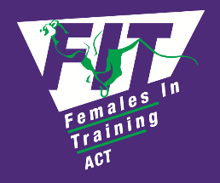
EXPENDITURE/REIMBURSEMENT
APPROVAL FORM

APPROVAL FOR EXPENDITURE/REIMBURSEMENT

Personal Details
Name
Email address
Phone number

Funding Request
Short description
Cost
Date of expenditure

Has this expenditure been approved by the FIT Committee?
Yes ⬜ No ⬜
Committee meeting date (if known): __________________________________

REIMBURSEMENT
If claiming personal reimbursement for a coaching accreditation, FA, or CPR, please attach the following and email to FIT Coaching Coordinator at coach@fitact.org.au
* a copy of the certificate/ statement of attainment
* a copy of an invoice showing payment
- this reimbursement form completed

How should this payment be made - please select one:
- FIT to pay on receipt of invoice: Yes ⬜ No ⬜
- FIT debit card: Yes ⬜ No ⬜
- Personal Reimbursement: BSB:
Account Number:
Account Name:

Approval
I confirm that I have approved the expenditure listed above as a legitimate FIT expense and recommend that the claim is reimbursed.
Coach/Committee Member signature _______________ Date: _____________

